Patrol Leader  Eagle Patrol • Waapi Lenaswa Platoon  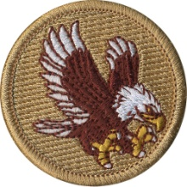 | Assistant Patrol Leader  Eagle Patrol • Waapi Lenaswa Platoon
First Aid Leader  Eagle Patrol • Waapi Lenaswa Platoon | Assistant First Aid Leader  Eagle Patrol • Waapi Lenaswa Platoon
Service Project Leader  Eagle Patrol • Waapi Lenaswa Platoon | Assistant Service  Project Leader  Eagle Patrol • Waapi Lenaswa Platoon  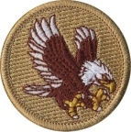
1st Assistant Patrol Leader  Eagle Patrol • Waapi Lenaswa Platoon | 2nd Assistant Patrol Leader  Eagle Patrol • Waapi Lenaswa Platoon
1st Assistant First Aid Leader  Eagle Patrol • Waapi Lenaswa Platoon | 2nd Assistant First Aid Leader  Eagle Patrol • Waapi Lenaswa Platoon

