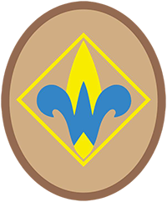

* 3-MILE HIKE ON THE WAUPONSEE GLACIAL TRAIL
* SERVICE PROJECT
* LEADERSHIP ROLES

Saturday, April 30, 2016, 9AM - 12N

County of Will

WILL COUNTY FOREST PRESERVE DISTRICT

17540 W Laraway Road, Joliet

*First Annual*

Webelos Walkabout

